IMPORTANT: All updates are to be made on the staging website only.

STAGING URL: https://hardyd21.sg-host.com/

The company has 3 centers:
- Oakville
- Bull Creek
- Watanobbi

IMPORTANT to know - We are ONLY work on Oakville and Bull Creek and NOT Watanobbi.

Agreed Actions as shared by Nick:
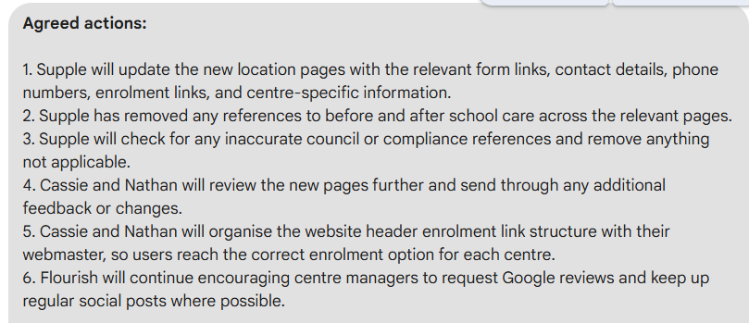

What has to be done:

Task 1:
The following section on https://flourishelc.com.au/flourish-early-learning-centre-oakville-nsw/:

Has to be added across all these 14 pages:
- https://flourishelc.com.au/daycare-childcare-oakville-nsw/
- https://flourishelc.com.au/daycare-childcare-box-hill-nsw/
- https://flourishelc.com.au/daycare-childcare-vineyard-nsw/
- https://flourishelc.com.au/daycare-childcare-gables-nsw/
- https://flourishelc.com.au/daycare-childcare-grantham farm-nsw/
- https://flourishelc.com.au/daycare-childcare-riverstone-nsw/
- https://flourishelc.com.au/daycare-childcare-mulgrave-nsw/
- https://flourishelc.com.au/preschool-oakville-nsw/
- https://flourishelc.com.au/preschool-box-hill-nsw/
- https://flourishelc.com.au/preschool-vineyard-nsw/
- https://flourishelc.com.au/preschool-gables-nsw/
- https://flourishelc.com.au/preschool-grantham-farm-nsw/
- https://flourishelc.com.au/preschool-riverstone-nsw/
- https://flourishelc.com.au/preschool-mulgrave-nsw/

Also, the following section on https://flourishelc.com.au/flourish-early-learning-bull-creek-wa/

Has to be added across all these 14 pages:

- https://flourishelc.com.au/daycare-childcare-bull-creek-wa/
- https://flourishelc.com.au/daycare-childcare-leeming-wa/
- https://flourishelc.com.au/daycare-childcare-bateman-wa/
- https://flourishelc.com.au/daycare-childcare-rossmoyne-wa/
- https://flourishelc.com.au/daycare-childcare-shelley-wa/
- https://flourishelc.com.au/daycare-childcare-willetton-wa/
- https://flourishelc.com.au/daycare-childcare-brentwood-wa/
- https://flourishelc.com.au/kindergarten-bull-creek-wa/
- https://flourishelc.com.au/kindergarten-leeming-wa/
- https://flourishelc.com.au/kindergarten-bateman-wa/
- https://flourishelc.com.au/kindergarten-rossmoyne-wa/
- https://flourishelc.com.au/kindergarten-shelley-wa/
- https://flourishelc.com.au/kindergarten-willetton-wa/
- https://flourishelc.com.au/kindergarten-brentwood-wa/

Task 2:
Across all these pages, post relevant Oakville-related images that can be taken from https://flourishelc.com.au/flourish-early-learning-centre-oakville-nsw/:

- https://flourishelc.com.au/daycare-childcare-oakville-nsw/
- https://flourishelc.com.au/daycare-childcare-box-hill-nsw/
- https://flourishelc.com.au/daycare-childcare-vineyard-nsw/
- https://flourishelc.com.au/daycare-childcare-gables-nsw/
- https://flourishelc.com.au/daycare-childcare-grantham farm-nsw/
- https://flourishelc.com.au/daycare-childcare-riverstone-nsw/
- https://flourishelc.com.au/daycare-childcare-mulgrave-nsw/
- https://flourishelc.com.au/preschool-oakville-nsw/
- https://flourishelc.com.au/preschool-box-hill-nsw/
- https://flourishelc.com.au/preschool-vineyard-nsw/
- https://flourishelc.com.au/preschool-gables-nsw/
- https://flourishelc.com.au/preschool-grantham-farm-nsw/
- https://flourishelc.com.au/preschool-riverstone-nsw/
- https://flourishelc.com.au/preschool-mulgrave-nsw/

Across all these pages, post relevant Bull Creek-related images that can be taken from https://flourishelc.com.au/flourish-early-learning-bull-creek-wa/:
- https://flourishelc.com.au/daycare-childcare-bull-creek-wa/
- https://flourishelc.com.au/daycare-childcare-leeming-wa/
- https://flourishelc.com.au/daycare-childcare-bateman-wa/
- https://flourishelc.com.au/daycare-childcare-rossmoyne-wa/
- https://flourishelc.com.au/daycare-childcare-shelley-wa/
- https://flourishelc.com.au/daycare-childcare-willetton-wa/
- https://flourishelc.com.au/daycare-childcare-brentwood-wa/
- https://flourishelc.com.au/kindergarten-bull-creek-wa/
- https://flourishelc.com.au/kindergarten-leeming-wa/
- https://flourishelc.com.au/kindergarten-bateman-wa/
- https://flourishelc.com.au/kindergarten-rossmoyne-wa/
- https://flourishelc.com.au/kindergarten-shelley-wa/
- https://flourishelc.com.au/kindergarten-willetton-wa/
- https://flourishelc.com.au/kindergarten-brentwood-wa/

Task 3:
Add contact CTA and neutral images on:
https://flourishelc.com.au/areas-we-serve/

Task 4:
Remove references to “before and after school care” across the relevant pages.

I found the mentions on 2 pages (through Colana and site query), but pls do verify if there are any other references you can find.

- On https://flourishelc.com.au/daycare-childcare-bateman-wa/ - Remove the FAQ “Do you offer before and after school care?” and the corresponding answer.
- https://flourishelc.com.au/areas-we-serve/ - Remove the FAQ “Do you offer before and after school care?” and the corresponding answer.

Task 5:
Client’s Request: Check for any inaccurate council or compliance references and remove anything not applicable. Some of the location pages have reference to different council rules being followed by Flourish but we will need to change that to make sure it’s correct council reference (for that centre) or simply remove those mentions to avoid confusion or conflict.

What updates to make:
The content team has removed all instances of mentions that referred to any Council’s, see document:
https://docs.google.com/document/d/17jKP5Cz0HG83pUkjmU3Fm2YJDXluI4Rp8oDFYJoiCn8/edit?tab=t.0

The changes are highlighted and we have to make those changes across the different pages.

